SERVICE & SUPPORT

Sub-Menu:-
- Sungrow Service- I. Service Brand, II. Service Stories
- Support for You- I. Installers Support, II. Homeowners Support, III. Business Owners Support
- Resources- 1. Product Documentation, II. FAQs, III. Warranty
- Success Stories- Cases & Stories

- I. Service Brand- (Hero photo like this)
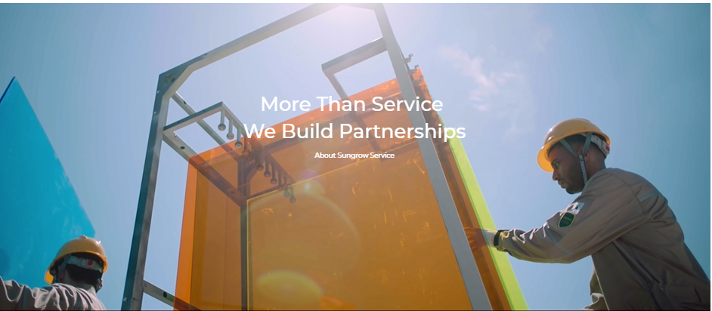

Professional Support. Reliable Performance.

At Oriana Inverters, our commitment goes beyond delivering high-quality solar inverters. We provide dependable service support throughout the product lifecycle, helping customers, installers, EPC partners, and businesses achieve reliable solar performance.
Our service approach combines technical expertise, responsive support, systematic troubleshooting, and field-level assistance to ensure faster resolution and minimal downtime.

OUR STRENGTH

- Installation & Commissioning Image
- Technical support Image
- Responsive Customer Support Image
- Troubleshooting & Diagnostics Image
- Warranty & Service Assistance Image
- Remote Support & Monitoring Image

OUR APPROACH
Identify → Diagnose → Resolve → Support
(All photos in same pattern)

GLOBAL PRESENCE
(Map showing locations- like used in OSG website)

II. Service Stories- Photos of installations and services.

- SUPPORT FOR YOU:
- Installers Support (as shown in Sungrow website)
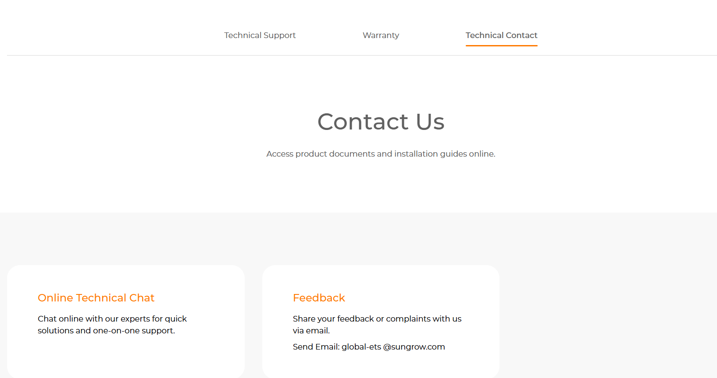

- Home Owners Support (as shown in Sungrow website)
- Business Owners support (as shown in Sungrow website)

- Resources-
- Product Documentation,
- Resource center image at start and followed by:
- Category wise all products documents available to download.

- II. FAQs,
- FAQs will be shared with you

- III. Warranty
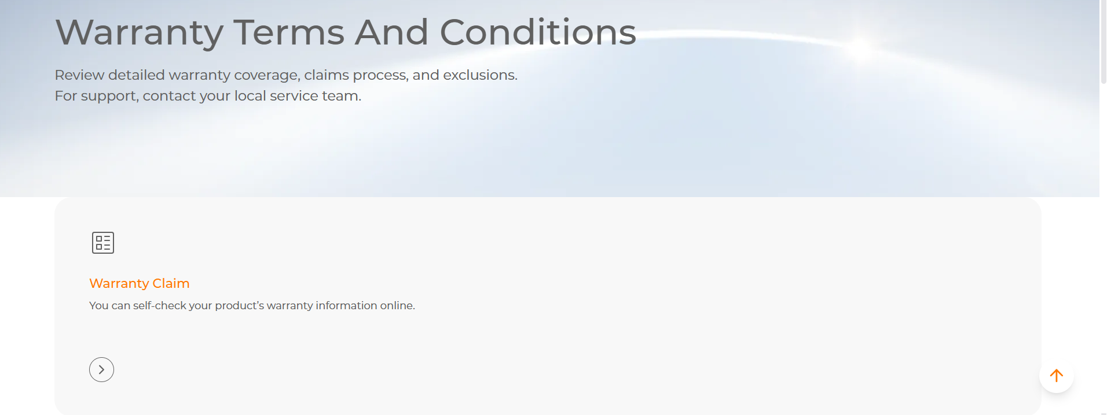

- Success Stories- Cases & Stories
- Category wise cases & stories (ongrid/hybrid/utility/BESS)

